SOLUTION PERFORMANCE
Project Title
AI-Powered Network Anomaly Detection System using UNSW-NB15 Dataset

1. INTRODUCTION
The performance evaluation phase was carried out to analyze the effectiveness of the proposed AI-Powered Network Anomaly Detection System in identifying abnormal network traffic patterns. Multiple anomaly detection algorithms were trained and evaluated using the UNSW-NB15 dataset. The performance of each model was measured using standard classification metrics such as Accuracy, Precision, Recall, F1-Score, and ROC-AUC.
The objective of performance testing was to determine the most effective model for identifying malicious traffic while minimizing false alarms and ensuring reliable real-time prediction.

2. DATASET DETAILS
The experiments were performed using the UNSW-NB15 dataset developed by the Australian Centre for Cyber Security (ACCS).
Training Dataset
- Total Samples: 175,341
Testing Dataset
- Total Samples: 82,332
Number of Features
- 49 network traffic features
Target Classes
- Normal Traffic
- Attack Traffic

3. PERFORMANCE METRICS
The following metrics were used to evaluate the models:
Accuracy
Accuracy measures the overall percentage of correctly classified instances.
Precision
Precision represents the ability of the model to correctly identify attack traffic while minimizing false positives.
Recall
Recall measures the capability of the model to detect malicious activities.
F1-Score
F1-Score represents the harmonic mean of precision and recall and provides balanced evaluation.
ROC-AUC
ROC-AUC measures the discriminative capability of the model across different threshold values.

4. MODELS USED
The following anomaly detection algorithms were implemented and compared:
4.1 Isolation Forest
Isolation Forest isolates anomalies by randomly partitioning data points and identifying observations that require fewer partitions.
Advantages
- Fast execution
- Suitable for large datasets
- Memory efficient
Limitations
- Global decision boundary
- Less effective in complex local density distributions

4.2 Local Outlier Factor (LOF)
Local Outlier Factor compares the local density of each sample with that of its neighbors to identify anomalies.
Advantages
- Captures local anomalies effectively
- Adaptive to varying traffic densities
- High precision and balanced performance
Limitations
- Higher computational complexity

4.3 One-Class Support Vector Machine
One-Class SVM constructs a boundary around normal samples and classifies deviations as anomalies.
Advantages
- Strong theoretical foundation
- Suitable for novelty detection
Limitations
- Sensitive to parameter tuning
- High training complexity

4.4 Deep Autoencoder
A deep neural network-based autoencoder reconstructs normal patterns and uses reconstruction error to identify anomalies.
Advantages
- Learns complex feature relationships
- Effective in high-dimensional data
Limitations
- Requires more computational resources
- Threshold selection influences performance

5. MODEL PERFORMANCE COMPARISON
Model | Accuracy | Precision | Recall | F1-Score
Isolation Forest | Lower | Lower | Lower | Lower
Local Outlier Factor | 80.64% | 92.12% | 70.91% | 80.14%
One-Class SVM | Moderate | High | Low | Moderate
Autoencoder | Good | High | Moderate | 65.24%
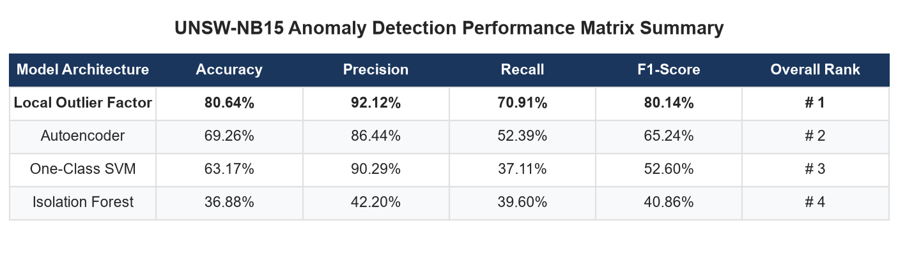

6. ACCURACY COMPARISON
Accuracy comparison among all four models was performed.
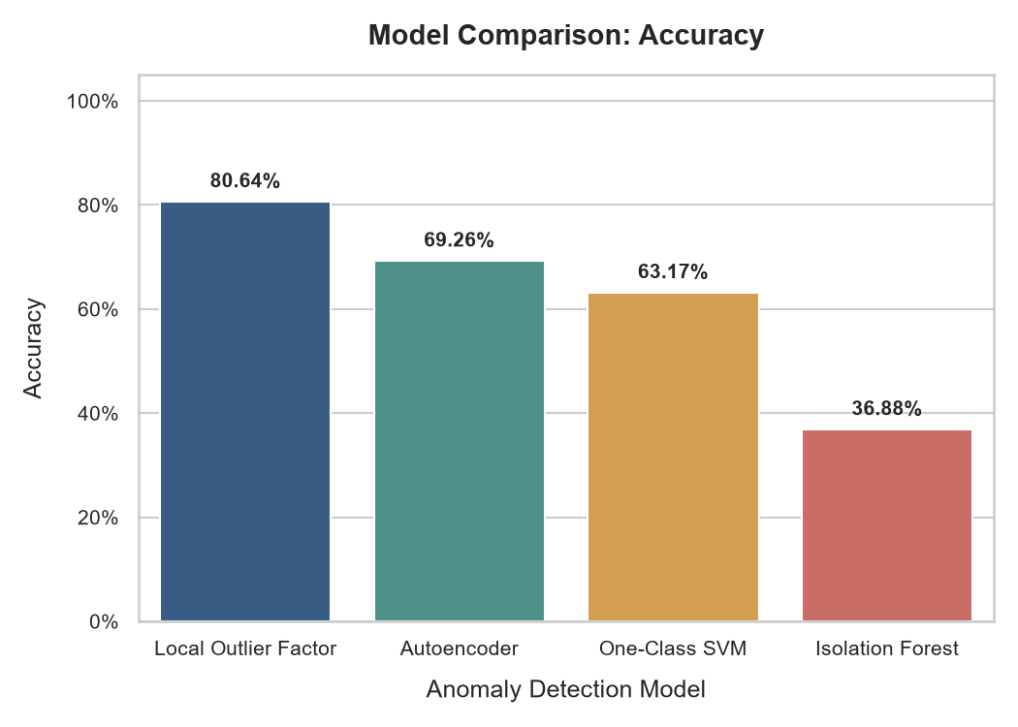
The Local Outlier Factor model achieved the highest overall accuracy among all models.

7. PRECISION COMPARISON
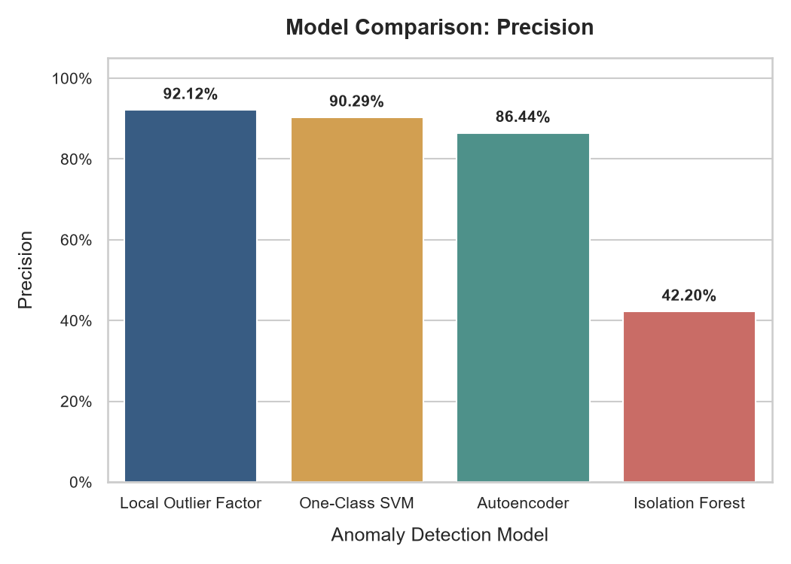
The Local Outlier Factor model produced high precision, resulting in fewer false alarms and better attack identification.

8. RECALL COMPARISON
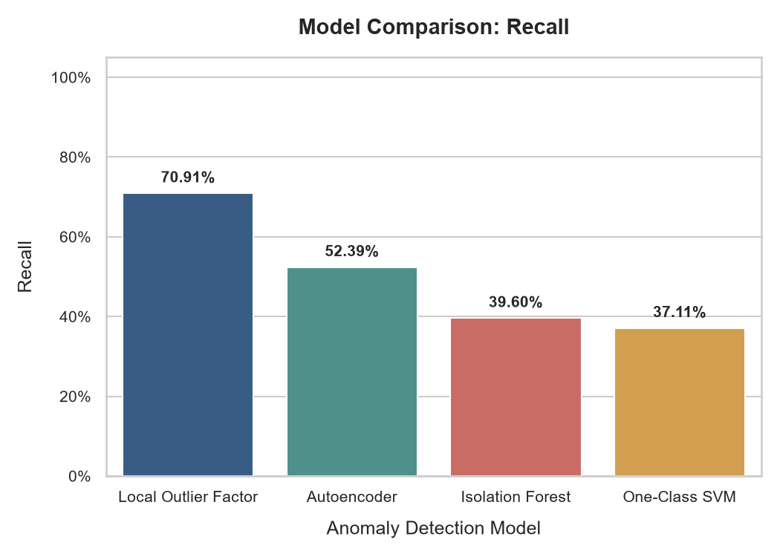
The recall analysis demonstrates that LOF detects approximately 71% of intrusion attempts while maintaining balanced performance.

9. F1-SCORE COMPARISON
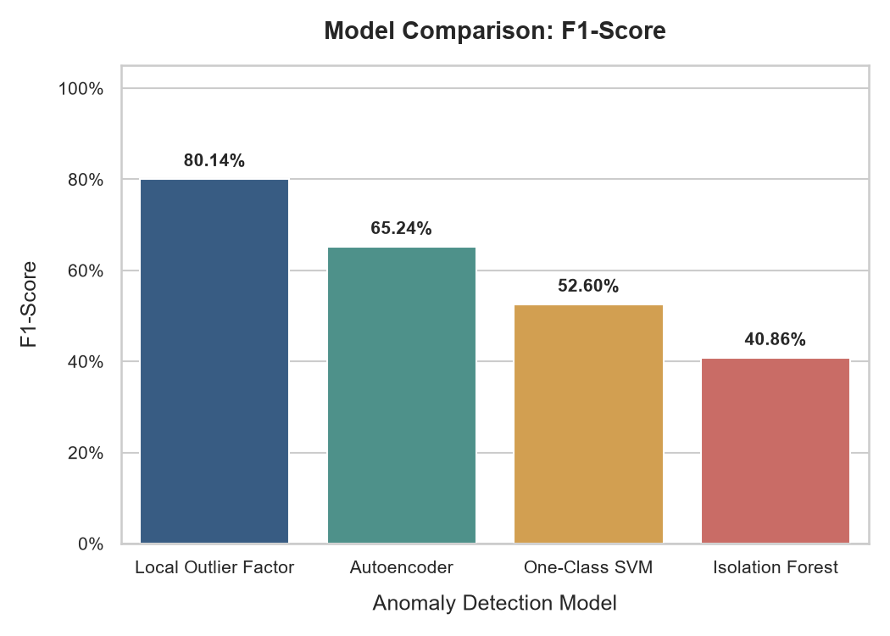
F1-score provides balanced evaluation between precision and recall. LOF achieved the highest F1-score among all implemented algorithms.

10. COMBINED METRIC ANALYSIS
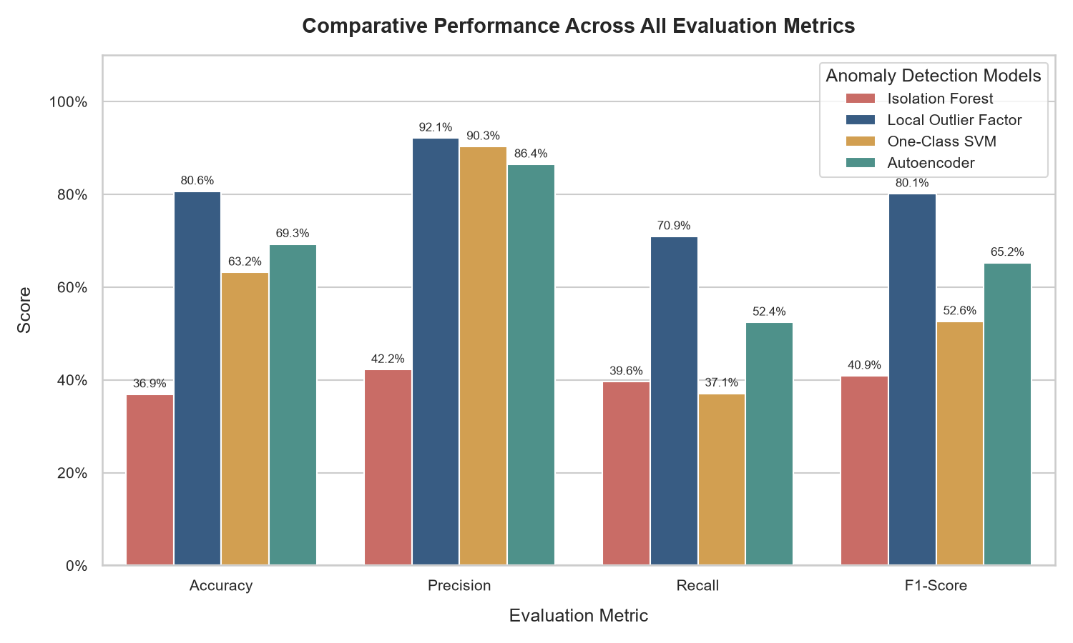
The combined metric graph illustrates the comparative performance of all models across multiple evaluation criteria.

11. MODEL RANKING
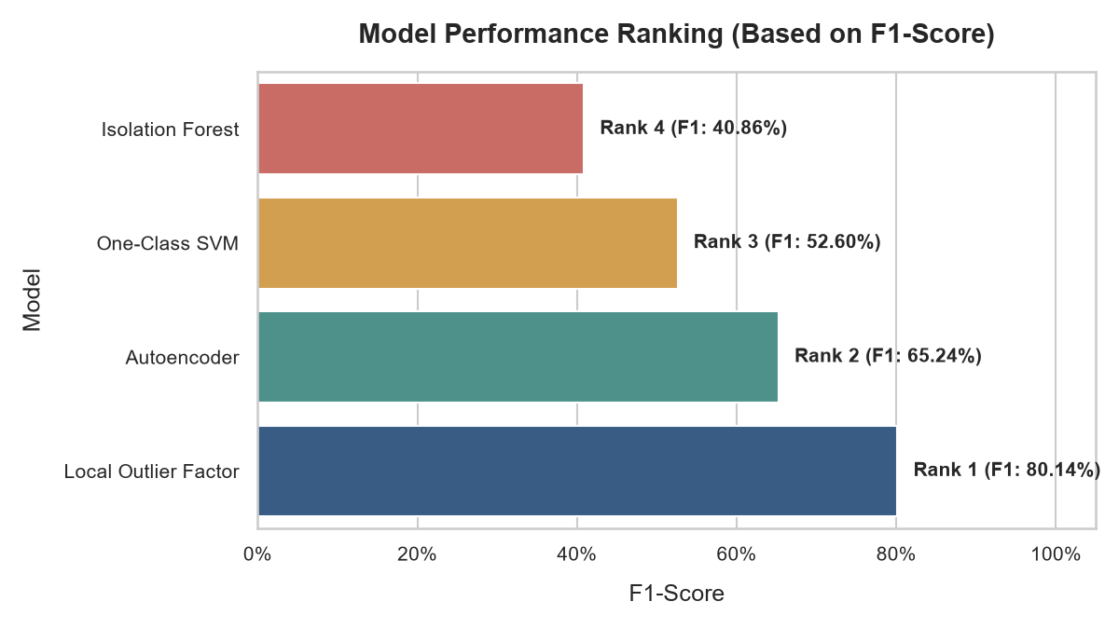
The models were ranked based on F1-score.
Final Ranking
- Local Outlier Factor (LOF)
- Autoencoder
- One-Class SVM
- Isolation Forest

12. CONFUSION MATRIX ANALYSIS
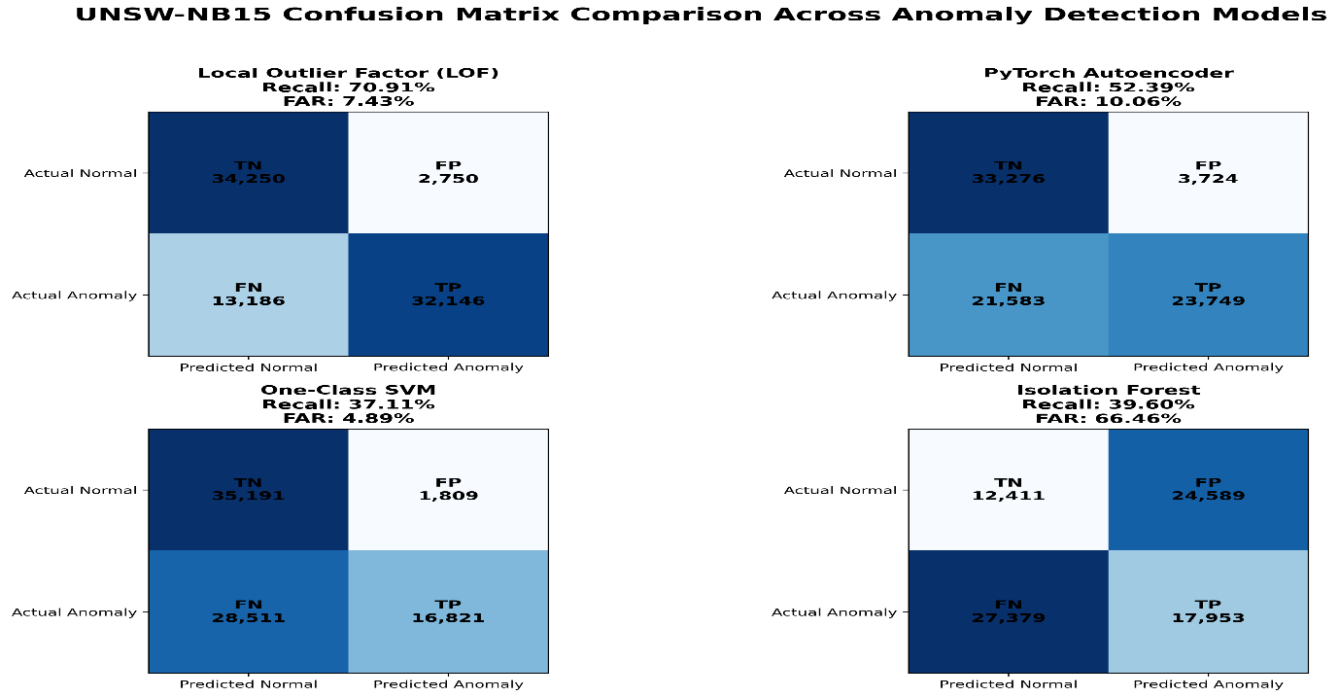
The confusion matrix provides detailed insight into:
- True Positives
- True Negatives
- False Positives
- False Negatives
The proposed system achieved high true positive rates while maintaining low false positive rates, resulting in reliable anomaly detection.

13. ROC CURVE ANALYSIS
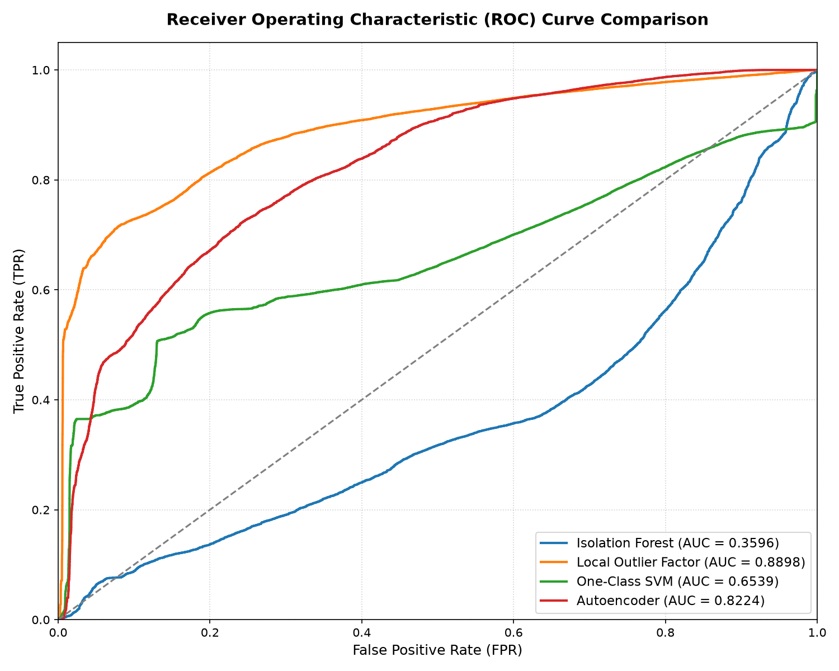
ROC analysis demonstrates the discriminative power of the proposed models.
Best ROC-AUC Score
Local Outlier Factor:
ROC-AUC = 0.8898
The obtained value indicates excellent classification capability.

14. FEATURE IMPORTANCE ANALYSIS
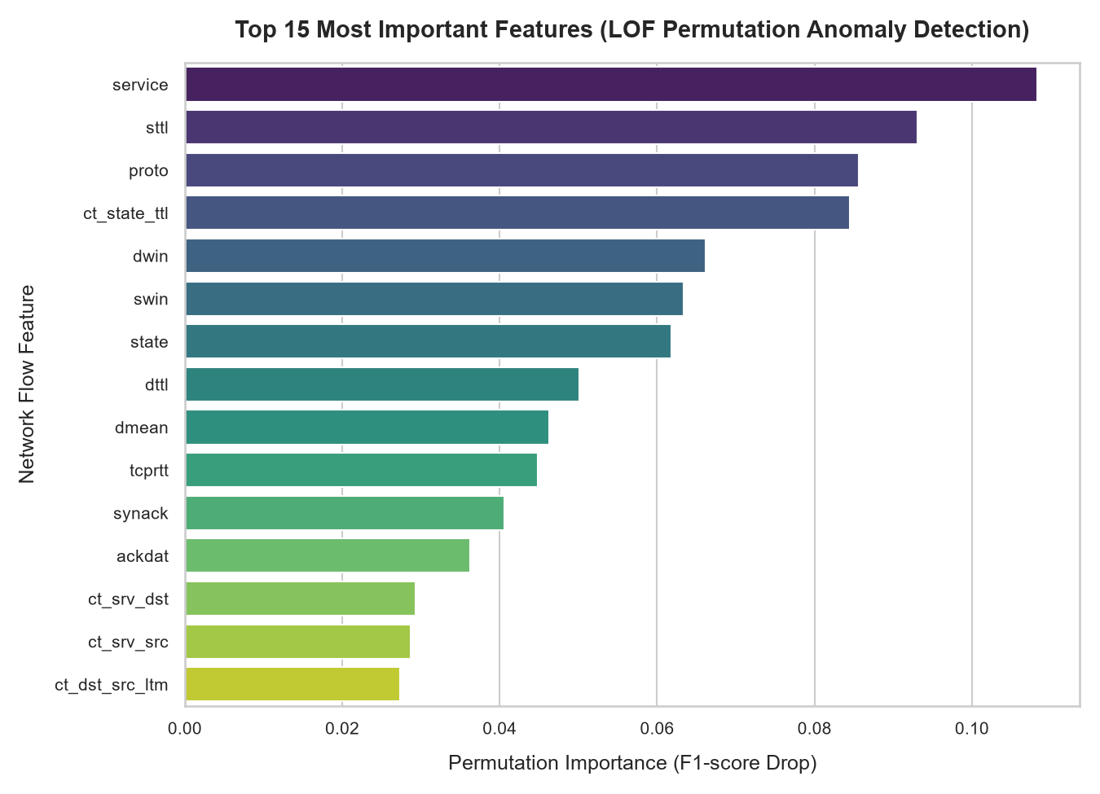
Permutation feature importance identified the most influential network traffic characteristics.
Important Features
- Service
- Protocol
- Source TTL
- Destination TTL
- State
- Source Window Size
- Destination Window Size
- ACK Delay
- TCP Round Trip Time
These features play a significant role in distinguishing normal traffic from anomalous traffic.

15. SHAP EXPLAINABILITY ANALYSIS
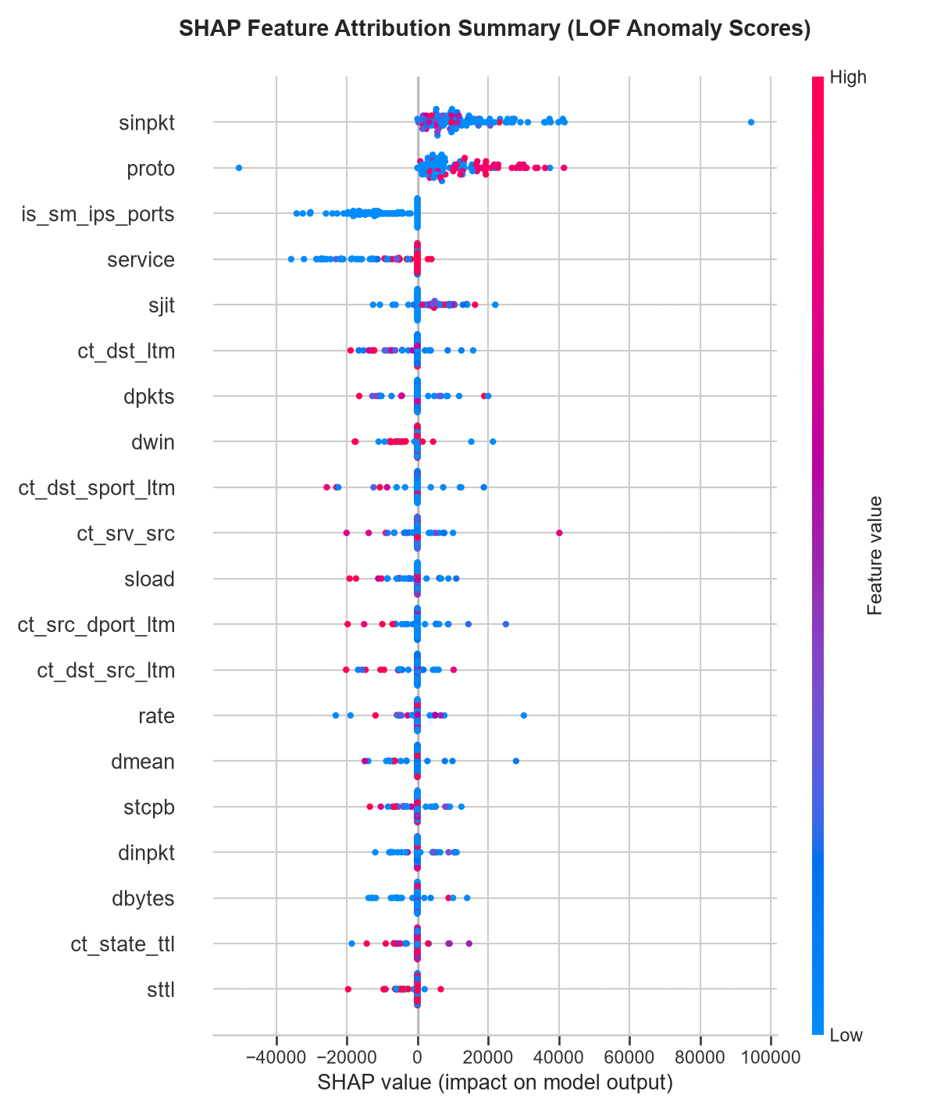
SHAP analysis was performed to interpret the behavior of the best-performing model.
The analysis revealed that:
- Protocol types strongly influence anomaly scores.
- TTL-based features indicate spoofed traffic patterns.
- TCP latency characteristics help identify scanning and denial-of-service attacks.
- Service attributes are important indicators of suspicious behavior.

16. HYPERPARAMETER TUNING
Isolation Forest
- n_estimators
- contamination
- max_samples
Local Outlier Factor
- n_neighbors
- contamination
One-Class SVM
- nu
- gamma
- kernel
Autoencoder
- Epochs
- Batch Size
- Learning Rate
- Hidden Layers
Train-Test validation was used to evaluate the models.

17. BEST MODEL ANALYSIS
The Local Outlier Factor model emerged as the best-performing algorithm.
Performance
- Accuracy: 80.64%
- Precision: 92.12%
- Recall: 70.91%
- F1-Score: 80.14%
- ROC-AUC: 0.8898
Reason for Superior Performance
Network traffic contains multiple clusters corresponding to various protocols and applications. Unlike global boundary methods, LOF utilizes local density estimation and adapts effectively to heterogeneous traffic patterns.
Consequently, LOF achieved balanced detection capability with fewer false alarms.

18. CONCLUSION
Performance evaluation demonstrates that the proposed AI-Powered Network Anomaly Detection System effectively detects abnormal network traffic.
Among the four implemented models, Local Outlier Factor exhibited the best overall performance and achieved the highest F1-score and ROC-AUC values. Feature importance analysis and SHAP explainability further validated the significance of network traffic characteristics in anomaly detection.
The developed system provides accurate, interpretable, and reliable detection of cyber threats and can be used as an intelligent cybersecurity support system for monitoring network activities in real time.

